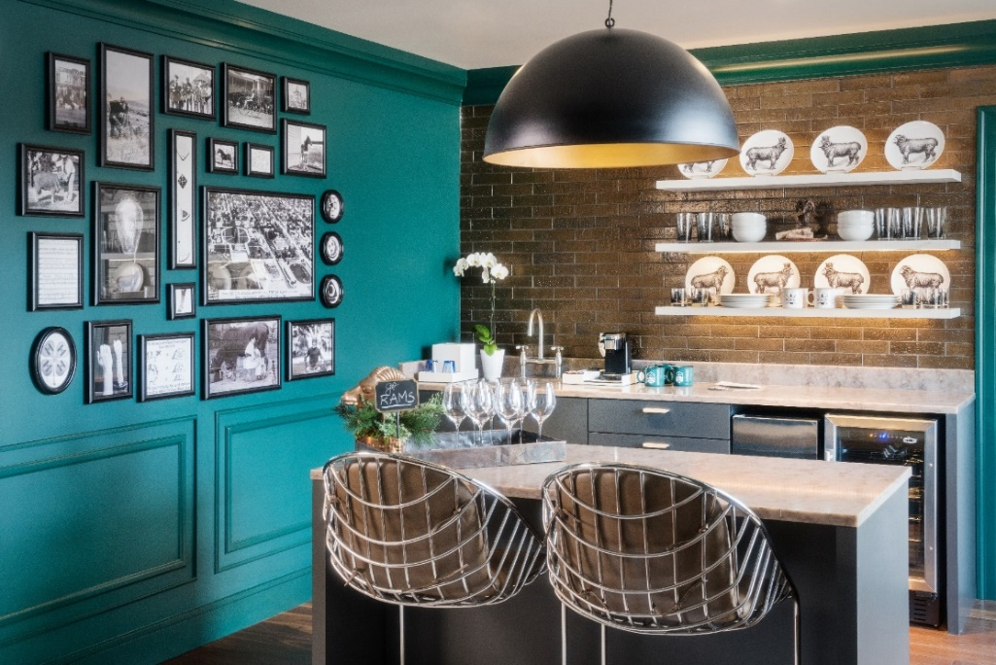
The Elizabeth Hotel’s special offers for CSU Employees

Rooms Rates:
- 15% Off our best available rate. Use the link here:
Book your corporate rate for Colorado State University
- For group needs of 10 or more rooms, please email: sales@theelizabethcolorado.com

Meeting & Special Event Rooms:
- Walnut Ballroom (2,605 square feet). Current maximum occupancy: 100
- Chestnut Ballroom (1,088 square feet). Current maximum occupancy: 40
- Sunset Lounge (2,172 square feet). Current maximum occupancy: 41 indoors, 57 indoor/outdoor
- Magic Rat (2,800 square feet). Current maximum occupancy: 118 indoors, 152 indoor/outdoor
- The Emporium (2,971 square feet). Current maximum occupancy: 138
Outdoor Spaces:
- 2nd floor Terrace (5,551 square feet). Current maximum occupancy: 175
- Magic Rat Patio (1,036 square feet). Current maximum occupancy: 42

PLEASE NOTE:
- Enhanced COVID distancing guidelines and special cleanliness and food / beverage protocols are now in place for all meetings and events!
- Event space pricing varies based on dates, times, and spaces needed but we are now offering a special CSU Employee discount on all personal event space bookings, please inquire for your specific needs.
- Max capacities for spaces listed are based on legal capacities and county levels for social distancing capacities; ie: our normal capacities at 50%, with a max of 175 total guests. These numbers do not account for special set up requirements; please inquire for your group and we can recommend the best space for your needs.

